Édouard Manet (1832 - 1883)

Édouard Manet was a French painter who is aligned with the Realist movement. He had many friends among the Impressionists and there was a mutual exchange of ideas but he never exhibited with them. Throughout his career, he continued to submit works to the official Paris Salon, where his most famous scandals, Déjeuner sur l’herbe (Luncheon on the Grass, 1863) and Olympia (1863), were displayed. Manet, much like the Realist artist Gustave Courbet, was inspired by contemporary life which was rendered on a scale previously reserved for historical and religious subjects. In addition, his subjects are depicted in an unidealised manner that defied the subject and style of the Salon. Manet’s relations with the Salon remained contentious throughout his career but he never openly renounced this institution even though he had close ties with the Impressionists who had their first independent exhibition in 1874. Manet’s work of the 1870s began to show the influence of Impressionism with an increased sketchiness of brushwork, more vibrant colours and outdoor scenes. Manet died in 1883 at the age of 51. Ironically, only one year later his reputation began to rise as the École des Beaux-Arts, Manet’s most consistent critic, organised a posthumous exhibition of 179 of his works. Manet’s artistic legacy has continued to gain in importance up to today.

Manet came from an upper-bourgeois family and did not need to earn money from his painting. In 1850 he began to study with Thomas Couture and his earliest pieces were copies made from works by old masters in the Louvre. By 1860, Manet began to paint scenes of contemporary life with a darker palette which was influenced by the artists he studied as a student. Due to Manet’s emphasis on scenes of contemporary urban life he is associated with the flâneur, a social figure who is discussed by Charles Baudelaire in his Painter of Modern Life (1863). The flâneur was the emblematic figure of the modern metropolis who visually consumed the rapidly changing spectacle of Paris.

The year 1863 marked a milestone for both Manet and the Salon. So many works were rejected that year by the jury that the Emperor created the ‘Salon des refusés’ (Salon of the Refused). Also in that year, Manet’s Déjeuner sur l’herbe was the focal point of mockery. The public objected to the nude and semi-nude women being placed within a contemporary setting with two fully clothed men. The work is currently interpreted as a modernist homage to Titian and Raphael; however, Manet’s contemporaries were affronted by the lack of clear meaning, the flattened figures and the unmodulated painting surface. Olympia caused a second enormous scandal at the 1865 Salon. Although Manet did not openly invite scandal, his works undermined the traditional expectations of the Salon viewers. The audience was confronted by images, not of goddesses or heroic episodes of the past, but by scenes of contemporary life that denied a clear narrative explanation. Manet continued to submit works to the Salon throughout his career, however, the establishment maintained a hostile attitude toward his work. Manet’s willingness to risk public censure through his dedication to innovation would inspire generations of later artists, although he did not have any direct followers.

References and further reading

Adler, K. (1986) Manet, Oxford: Phaidon.

Armstrong, C. M., & Manet, É. (2002). Manet Manette, New Haven: Yale University Press.

Baudelaire, C. (1964). The painter of modern life, and other essays, (J. Mayne, Trans.). London: Phaidon.

Clark, T. J. (1985). The painting of modern life: Paris in the art of Manet and his followers, New York: Knopf.

Guégan, S., & Sollers, P. (2011). Manet: The man who invented modernity, Paris: Gallimard.

See image below from Artstor [http://library.artstor.org/library/#1] with their identifying information

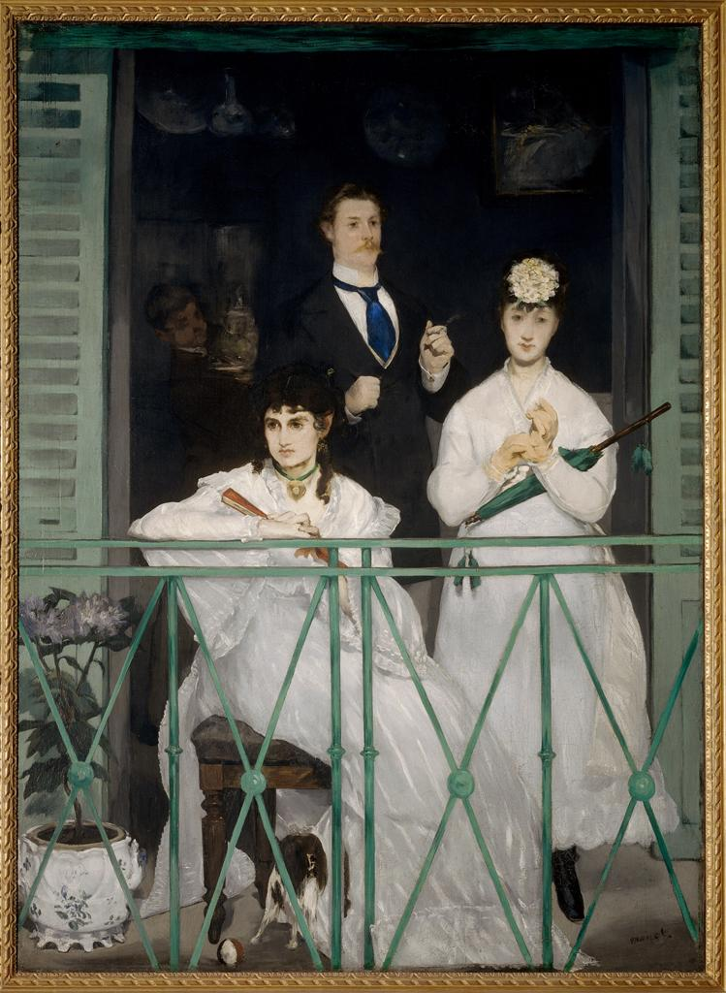

Creator | ?duard Manet
Title | Balcony
Work Type | painting
Date | 1868
Material | oil on canvas
Measurements | 1.7 x 1.245 m
Repository | Mus?e d'Orsay
ARTstor Collection | Italian and other European Art (Scala Archives)
Source | Image and original data provided by SCALA, Florence/ART RESOURCE, N.Y.  http://www.artres.com/c/htm/Home.aspx  http://www.scalarchives.com
Rights | (c) 2006, SCALA, Florence / ART RESOURCE, N.Y.  Please note that if this image is under copyright, you may need to contact one or more copyright owners for any use that is not permitted under the ARTstor Terms and Conditions of Use or not otherwise permitted by law. While ARTstor tries to update contact information, it cannot guarantee that such information is always accurate. Determining whether those permissions are necessary, and obtaining such permissions, is your sole responsibility.
Download Size | 10,241,024

